Progress report: Mechanisms underlying the interactive effect of temperature spikes and habitat conversion on nesting birds

# Background and significance of project

Habitat conversion to agriculture and ongoing climate change will determine the fate of biodiversity in the Anthropocene. Many forms of habitat conversion (e.g., agricultural expansion, urbanization) remove insulating tree canopies, thereby reducing local thermal buffering and exposing organisms to extreme heat. Temperatures on farms are often >10°C hotter than nearby natural sites. Both increased heat and less vegetation cover may accelerate evaporation, reducing water available to organisms for use in thermoregulation, and further exacerbating the effects of heat. Alternatively, irrigation on agricultural lands might compensate for water lost to evaporation. We might thus expect the effects of climate change on species living in natural and anthropogenic ecosystems to differ, given the vastly different thermal and water regimes present in each habitat. Physiological heat effects (i.e., overheating of nestlings) and food supply reductions are two main mechanisms through which heat might decrease the growth and survival of birds. Furthermore, we expect that irrigation and other sources of water will increase growth and survival of nestlings during hot periods.

# Summer 2021-2022 activities

Our study leverages a large network of songbird nest boxes in California’s Central Valley, established by the UC Davis Museum of Wildlife and Fish Biology (MWFB) in 2000 (i.e., the Putah Creek Nestbox Highway). Our focus is on the two most common nest box species: Tree Swallow and Western Bluebird, both of which nest in nest boxes in all four studied land uses. Birds in this area experience extreme temperatures while nesting, with temperatures regularly soaring over 40 degrees Celsius. The system is therefore ideal to study whether closed canopies buffer nesting birds from temperature spikes. Furthermore, the system stretches across a mosaic of natural and agricultural lands, allowing for the exploration of the role of irrigation and water availability in mediating the effects of heat.

The MWFB maintains 165 boxes across 8 sites along Putah Creek. Most boxes are in riparian forest habitat, but two sites, with 10 boxes each, are in orchards. In 2021, we supplemented this main network with two existing grassland sites (~30 boxes each) located on City of Davis and Putah Creek Riparian Reserve (PCRR) land, both of which have been monitored for multiple years by members of the Patricelli lab at UC Davis. We also obtained permission from PCRR, UC Davis Foundation Plant Services, Russell Ranch, and the UCD-H.M. Clause Innovation Center to supplement the Nestbox Highway with five sites of ten boxes each: three sites in row crops, one in orchard, and one in grassland. In 2022, we added four sites of 10 boxes each with permission from Full Belly Farms.

In April-August 2021 and 2022, we visited all boxes weekly and recorded the contents of each box (nest status, contents, species, etc). From the occupied boxes, we selected ~20 active nests per habitat type for monitoring (N= 80 boxes; 20 boxes/habitat * 4 habitats; at end of season 2021, 71 boxes monitored; in 2022, 161 boxes monitored). We used a fisheye lens to take a standardized picture of the canopy cover at each box and placed temperature loggers inside and outside each nest to record temperature every 5 min from egg-laying to fledging. We also placed one relative humidity sensor per site to track water availability. To quantify nestling growth and survival, we visited active nests each week, hand-captured nestlings, and collected morphometric growth data (nestling weight, wing chord, tarsus length, and bill length). We tracked each individual nestling’s growth by painting its nails with colored nail polish. One to two weeks prior to fledging, we affixed a small metal leg band to the nestling’s leg. In 2022, we collected a small blood sample to quantify nestling stress. During Fall 2022/Winter 2023, we will quantify the amount of corticosterone (a stress hormone) in each sample.

From these intensively monitored nests, we selected two to three per site to quantify food provisioning rates (at end of 2021 season, N = 19 nest attempts monitored for food provisioning: 5 in orchard, 6 in row crops, 3 in forest, and 5 in grassland; in 2022, N = 29). To do so, we affixed a Raspberry Pi-based motion-activated camera to the side or top of the box that saved videos 30 seconds before and after each motion activation. We will quantify hourly provisioning rate by using an image recognition algorithm to identify adult arrivals.

# Significance

Understanding when and where physiological stress and reduced food supply contribute to decrease reproductive success under temperature spikes in agriculture and other land uses will provide concrete avenues through which working landscapes could be modified to better accommodate birds. If the direct effects of heat are more important than food-mediated effects, providing microclimate refugia (e.g. shade trees) in agriculture may buffer temperature spikes to some extent, or nest boxes could be modified to reduce their internal temperature (e.g. by painting them with white or reflective paint). If food-mediated effects predominate, then maintaining patches of non-crop habitats in working landscapes to support food resources and provide thermal refuges for parents may be more effective. Furthermore, understanding the role that irrigation may play in mediating the effects of heat on wild birds living in agriculture could inform co-management of water resources for both wildlife and people. Finally, the findings of this study will advance our knowledge of the ecology of working landscapes by clarifying the mechanistic underpinnings of the fitness consequences of heat in working landscapes.

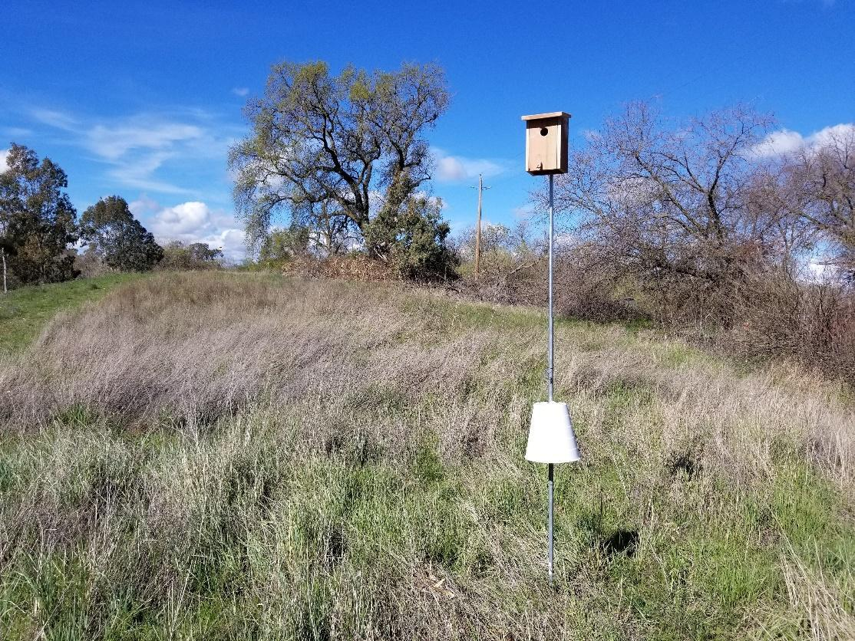

*One of the nestboxes we put up in early 2021.*